**Workflow for Selecting Photos (Desktop)**

*The following describes the workflow for customers to select photos from their photoshoot for their photography packages*

1. Customer clicks on a link provided by the photographer via email. From here, the customer selects the photo that they like for their package by clicking on the photo. The counter will reduce by 1 every time a photo is selected.  
   The customer can de-select the photo by clicking on the photo again.

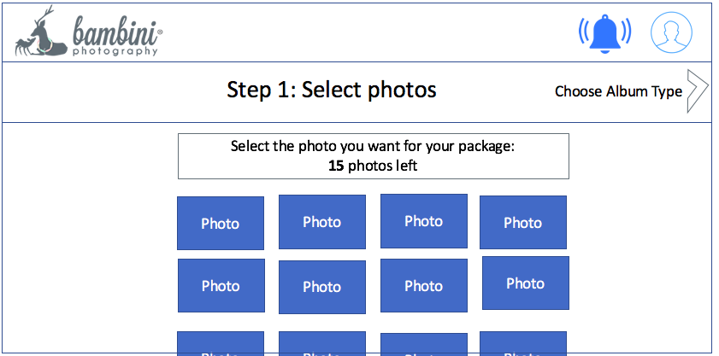

1. The customer proceeds to confirm the package that they have signed up for. If they have no packages, they skip this step and proceed straight to Step 3.

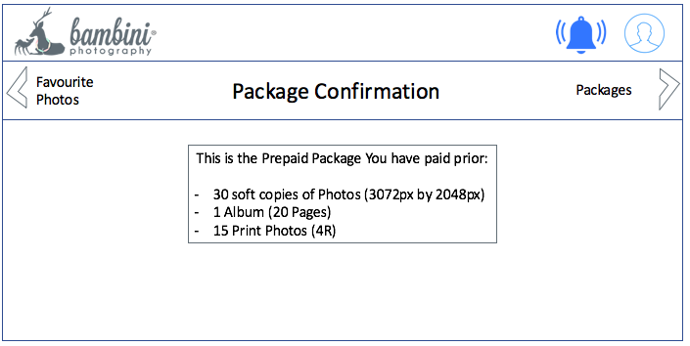

1. If the customer comes straight from step 1, they will be asked to add items for putting in their photos.  
   If the customer is coming from Step 2, they will be asked what item they will like to add on.

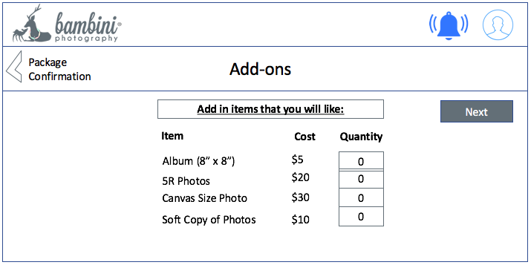

1. The customer selects the photo for the album page.   
   The customer can choose favourites to show only the photos they like, or all photos to show all photos regardless.   
   When the photo is selected, an indication is shown.  
   Once the photos are selected for a page, the customer clicks on “Next” to go to the next page of the album.

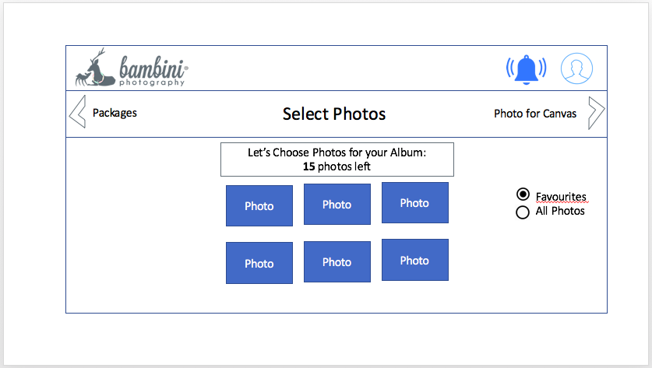

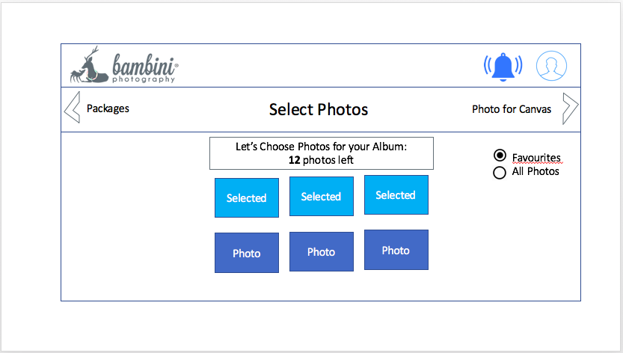

1. If the customer clicks on more than the number of photos allowed, the page will prompt the user if they would like to top up on pages for the album.  
     
   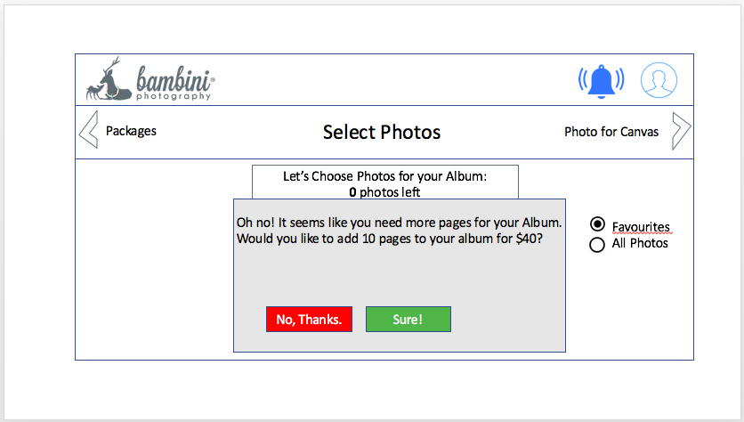
2. The client proceeds to select photos for their Canvas photo.

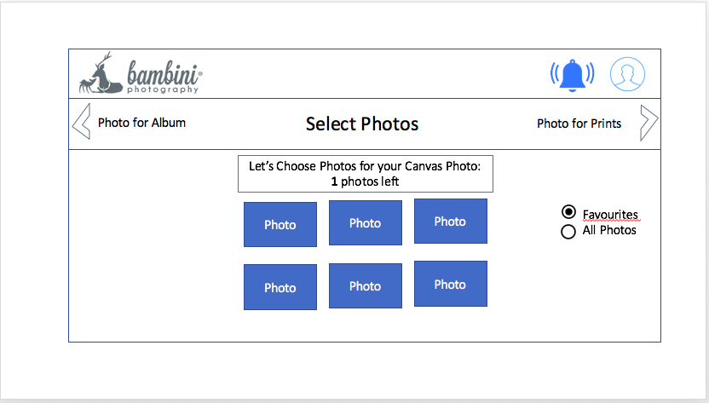

1. The client proceeds to select photos for their printed photos.

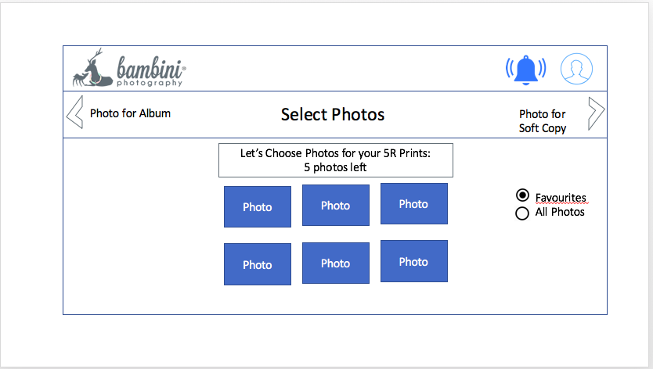

1. The client proceeds to select photos for their soft copies.

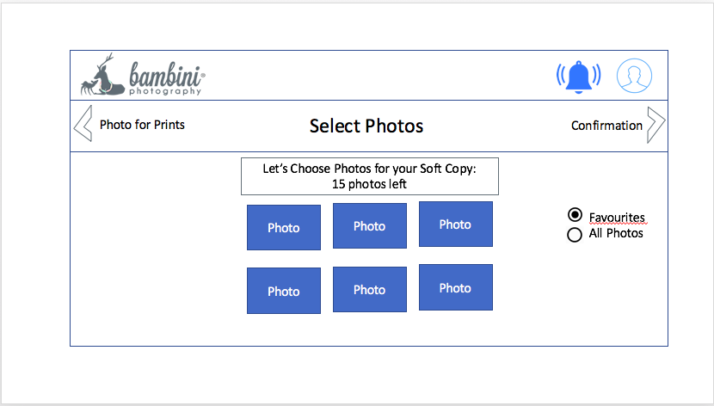

1. The client is shown a page confirming their order.  
   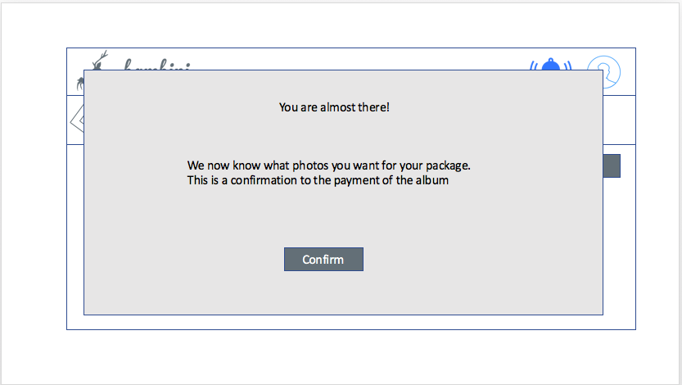
2. The client is shown the cost of the package, and presses “Pay” to make the payment.

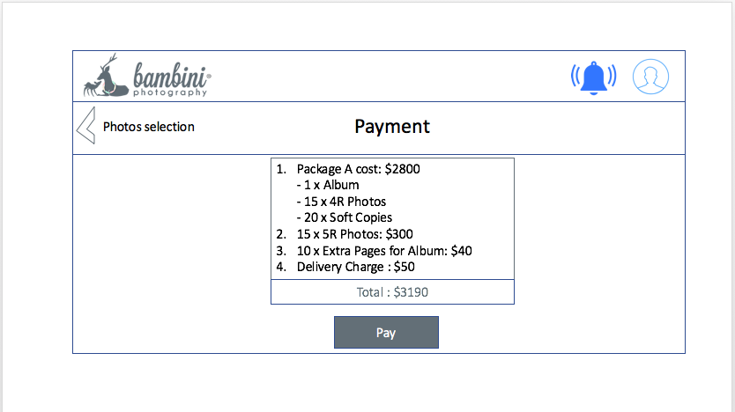

1. The client enters his/her details and clicks on “Pay” to confirm the payment.

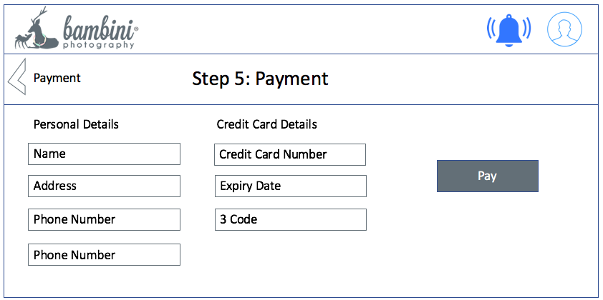

1. The client is shown a page confirming the successful payment.   
   If there are soft copies to download, an email will be sent to the user containing the download link.